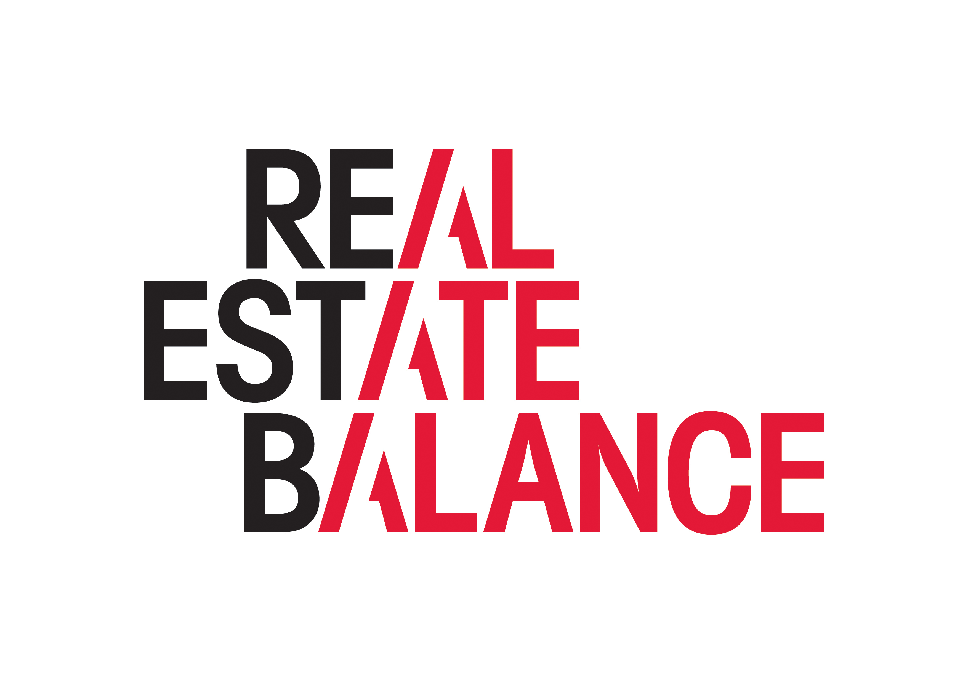
Mentee Brief
The aim of this brief is to provide a summary of how to prepare to participate as a mentee at our Speed Mentoring event.
Over the course of the event, you will have the opportunity to have 2 separate 30 minute mentoring sessions with two of leaders from across different areas of the real estate industry.
The aim of the session is to give you the opportunity to start to expand your network, understand more about what is current in the industry, and have a conversation with someone senior and independent around your career aspirations and development.
Mentoring is the pairing of an experienced individual (mentor) with a less experienced individual (mentee) with the aim of developing the mentee’s career. Mentors pass on valuable skills, knowledge and insights to mentees to help achieve this.
In preparation for your mentoring sessions:
- Develop a brief description of yourself that outlines what your journey has been so far, what you do now, any specific goals or aims and provides the context problems/challenges/issues you may be facing;
- Read about the mentors participating in the event and familiarise yourself with their career path, strengths and interests. Take time to do further research on particular areas of their expertise.
- Prepare questions on topics that you would like to know more about.
- Think about any problems/challenges/issues you have, if any, that they may be able to help with and set them within the context of your personal goals, priorities and values.
- Try to identify any options you are considering in order that you can discuss with your mentor any advantages or disadvantages of these options
The ask of you in your short time with your mentor is to:
- Come prepared to talk about yourself
- Ask questions, be confident to inquire about personal development
- Listen actively
- Keep an open mind and be open to feedback
- Respect confidentiality – this conversation should be treated confidentially by both parties
We will leave it up to the individual mentors and mentees as to whether any agreement is made as to follow-up, or further informal mentoring sessions. We would value your feedback on how the event goes, what you take away from it, and any suggestions for improvement for future sessions.
There will be plenty of time for networking and please do bring business cards.

