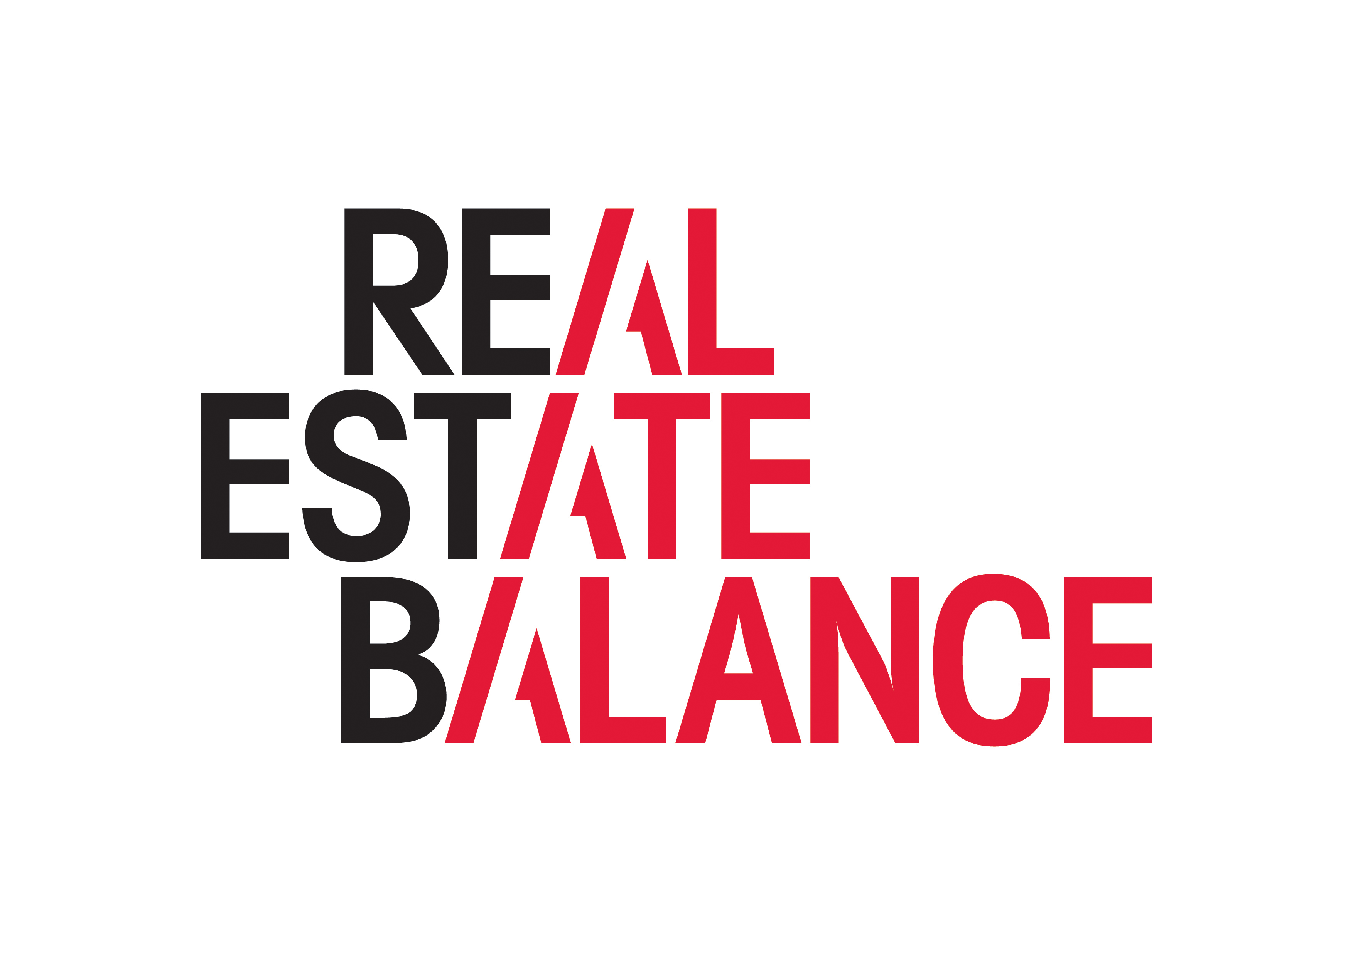

Mentor Brief
Over the course of the event, you will lead 2 x 20 minute sessions with 2 individuals from across the real estate industry.
The aim of the sessions is to give these individuals the opportunity to start to expand their network, understand more about what is current in the industry, and have a conversation with someone independent around their career aspirations and development.
Mentoring is the pairing of an experienced individual (mentor) with a less experienced individual (mentee) with the aim of developing the mentee’s career. As a mentor, you pass on valuable skills, knowledge and insights to your mentee to help them with this aim.
The ask of you in your short time with your mentor is to:
- Listen actively – we will ask the mentees to come prepared to talk a bit about themselves, what they do and their aims
- Share your experiences and insight into you and your career
- Give constructive feedback and provide coaching where relevant
- Respect confidentiality – this conversation should be treated confidentially by both parties
We will leave it up to the individual mentors and mentees as to whether any agreement is made as to follow-up, or further informal mentoring sessions.
We would value your feedback on how the event goes, what you take away from it, and any suggestions for improvement for future sessions. In addition, if you do continue your relationship with your mentee, please can you let us know (events@realestatebalance.org) so that we can track the success of these events and relationships built.
There will be plenty of time for networking and please do bring business cards.

